**Product & Sales Analysis**

1. Which products generate the highest revenue?

(SQL) (Python)

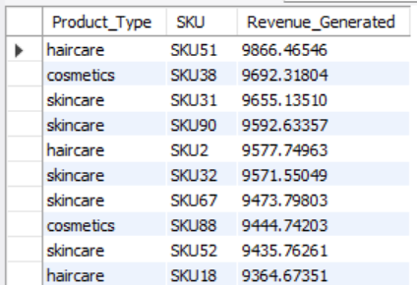 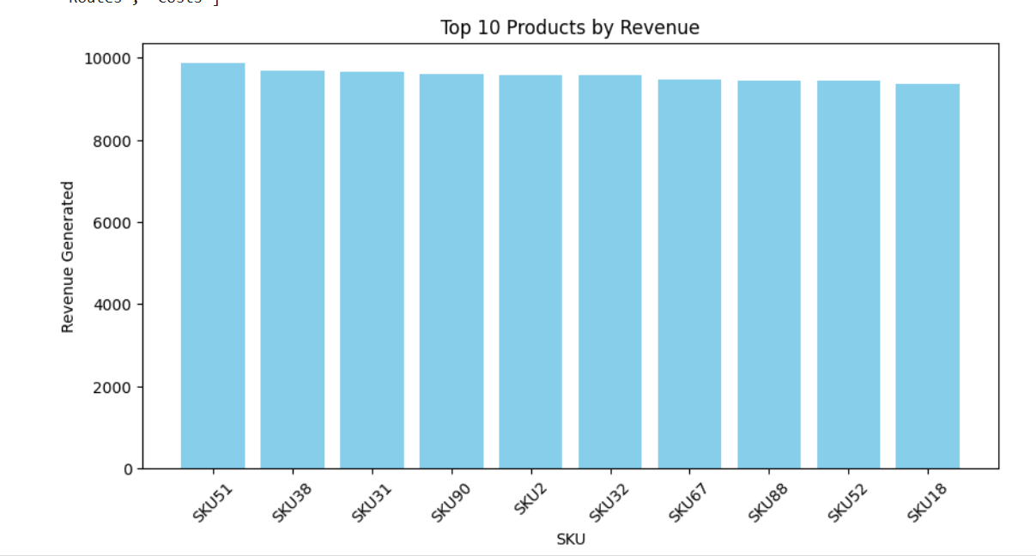

The highest revenue-generating products are **haircare SKU51, cosmetics SKU38, and skincare SKU31**, with revenues exceeding **$9600**. Haircare and skincare dominate the top-selling categories.

1. What is the correlation between price and the number of products sold?

(SQL) (Python)

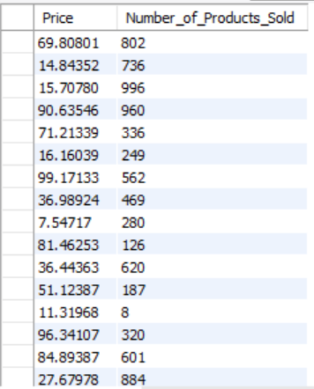 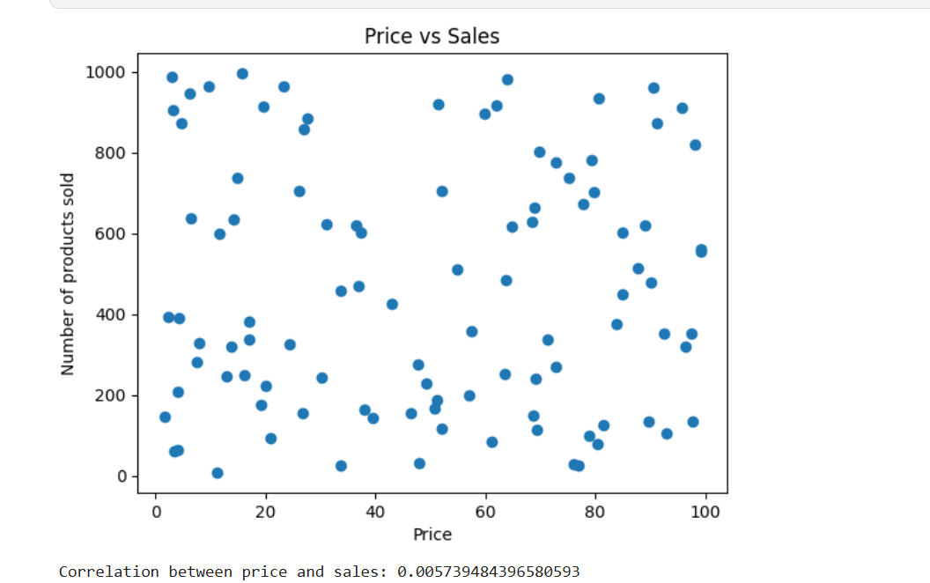

The correlation between **price and the number of products sold** is **0.0057**, indicating **almost no relationship** between price and sales volume. Price changes do not significantly impact sales.

1. How does product availability affect sales volume?

(SQL) (Python)

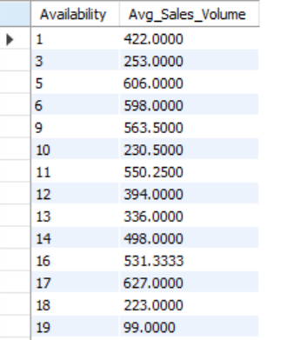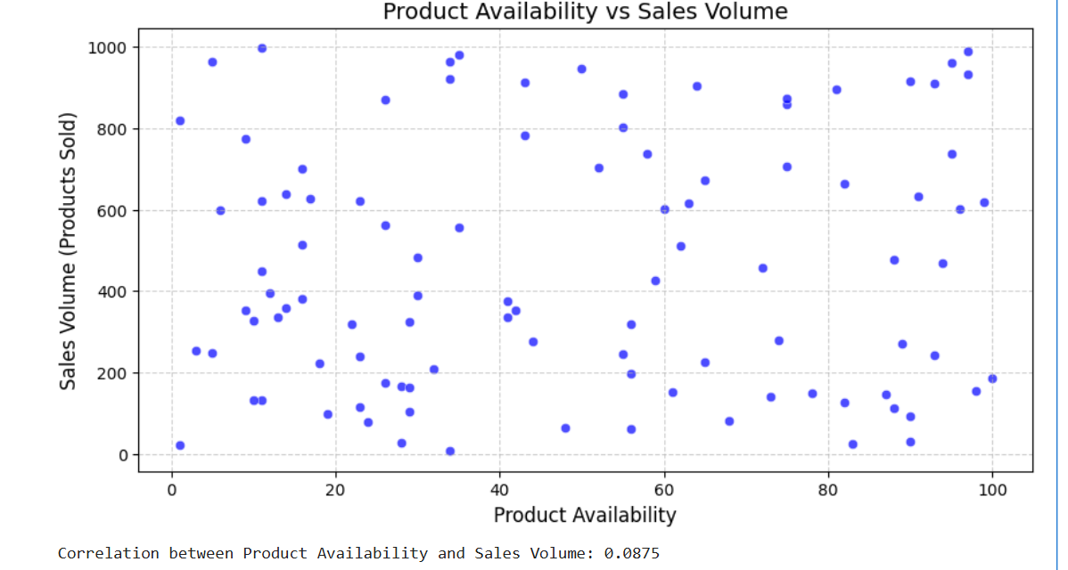

**Product availability has little correlation with sales volume, as shown by the scattered data points.** This suggests that other factors, such as demand or pricing, may have a greater impact on sales.

1. Are there specific SKUs that consistently perform better across different customer demographics?

(SQL) (Python)

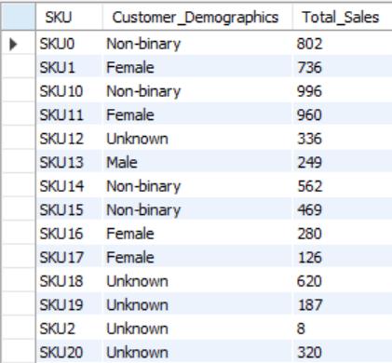 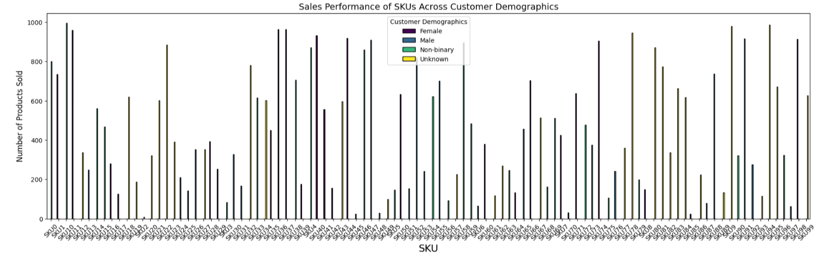

**Some SKUs, like SKU10 and SKU11, consistently perform well across multiple customer demographics.** The bar chart confirms that specific products appeal to diverse groups.

1. What are the best-selling products in each customer demographic?

(SQL)

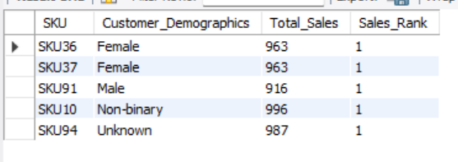 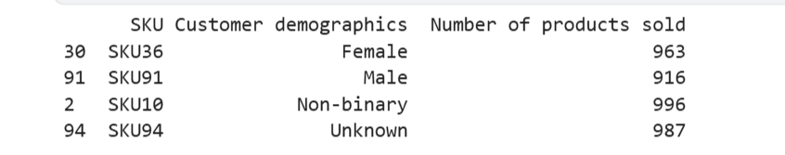

**Each customer demographic has a distinct best-selling product, with SKU10 leading among non-binary customers and SKU36 among females.** The table confirms sales rankings for each group.

**Inventory & Stock Management**

1. What are the stock levels for different SKUs, and how do they compare to sales trends?

(SQL) (Python)

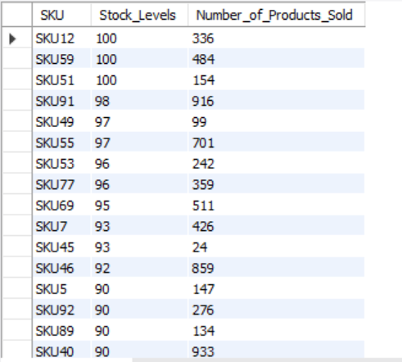 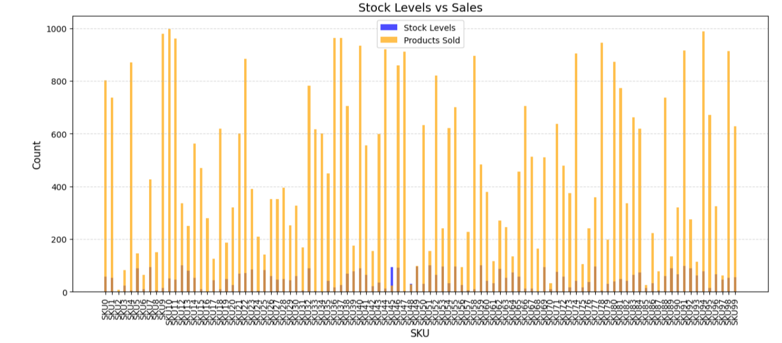

Stock levels vary across SKUs, with some high-selling products having **low stock**, indicating a need for restocking. **Sales trends are inconsistent with stock levels**, suggesting potential supply chain inefficiencies.

1. How often do stockouts occur, and which products are most affected?

(SQL) (Python)

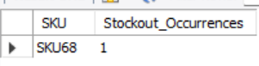 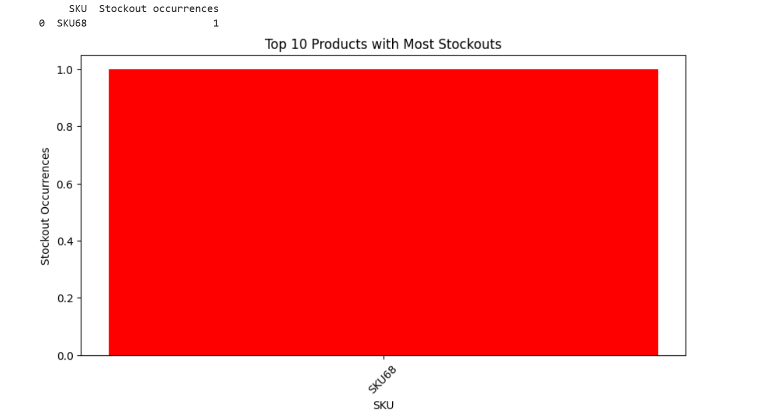

**Stockouts are rare, with SKU68 being the only product affected.** The bar chart highlights its occurrence, indicating potential supply chain inefficiencies.

1. Are there seasonal trends in stock depletion?

(SQL) (Python)

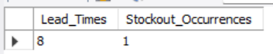 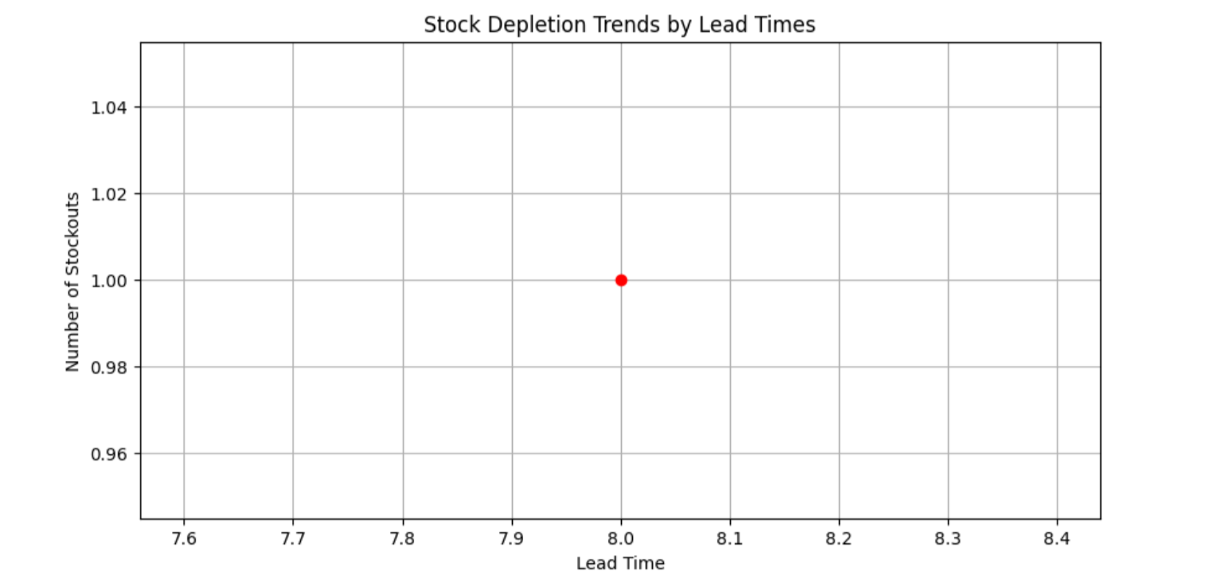

**No strong seasonal trends in stock depletion are observed, with stockouts occurring sporadically.** The data suggests that stock depletion may be influenced by factors other than lead times.

1. How do lead times impact stock levels?

(SQL) (Python)

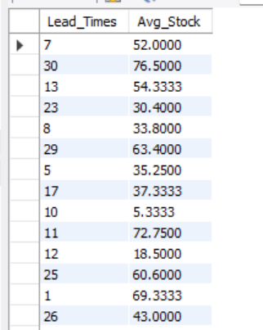 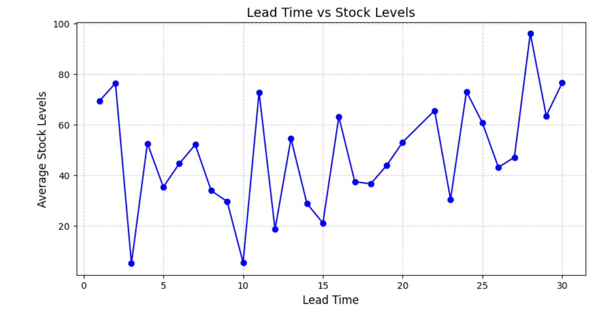

Lead times show a **fluctuating impact on stock levels**, with longer lead times generally associated with **higher average stock** levels. This suggests that businesses may **overstock to compensate for delays** in supply.

1. What reorder quantities optimize inventory costs while preventing stockouts?

(SQL) (Python)

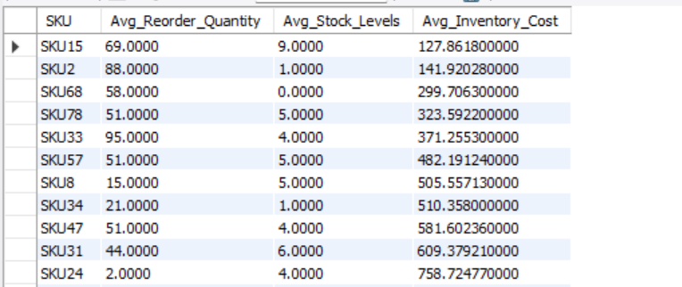 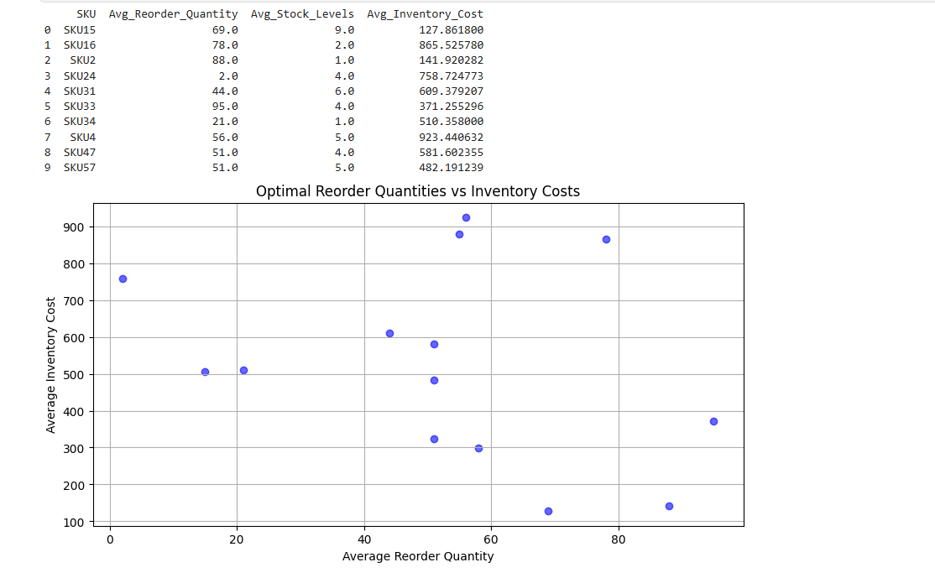

**Optimal reorder quantities balance inventory costs while preventing stockouts.** The scatter plot shows varying reorder levels, indicating that larger reorder quantities generally lead to higher inventory costs.

**Supplier & Manufacturing Analysis**

1. Which suppliers provide the fastest lead times?

(SQL) (Python)

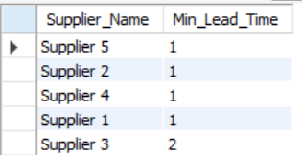 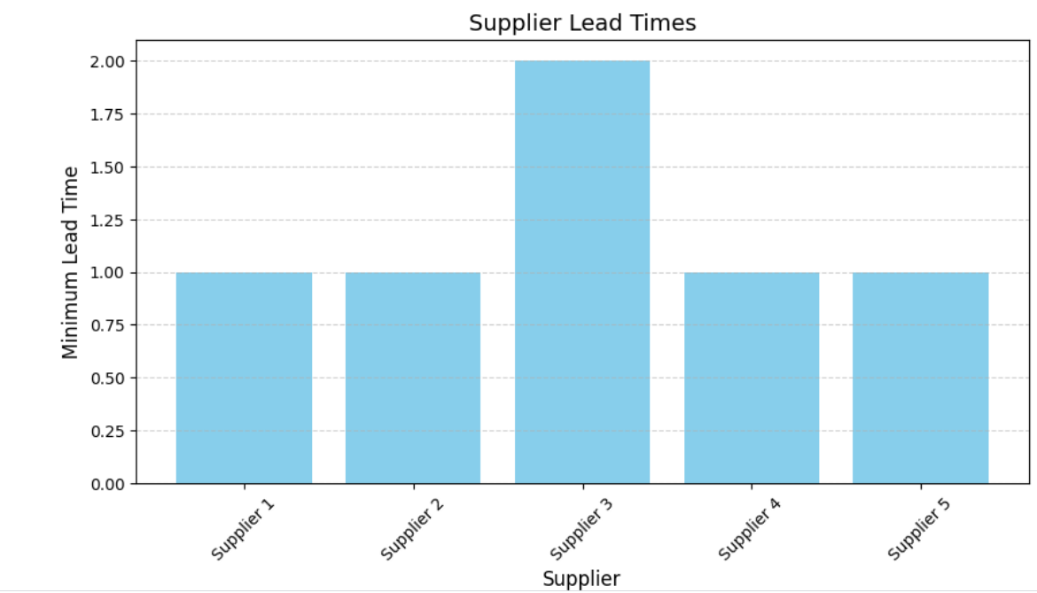

**Suppliers 1, 2, 4, and 5** provide the **fastest lead times** with a minimum lead time of **1 day**, while **Supplier 3** has a slightly longer lead time of **2 days**.

1. Is there a relationship between supplier location and lead time?

(SQL) (Python)

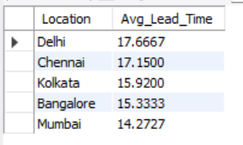 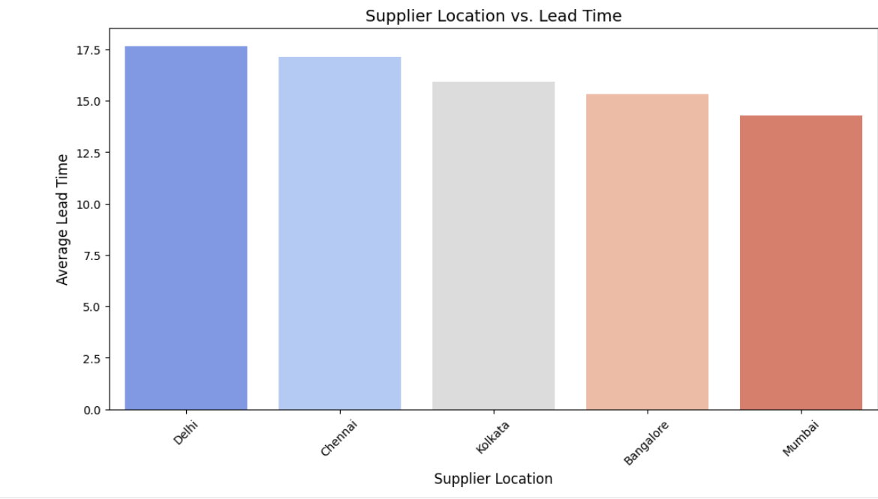

**Suppliers in Delhi and Chennai have the longest lead times, while Mumbai has the shortest.** The bar chart confirms regional differences in supplier efficiency.

1. How do manufacturing lead times compare across different products?

(SQL) (Python)

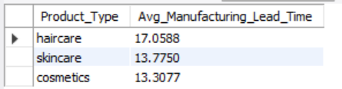 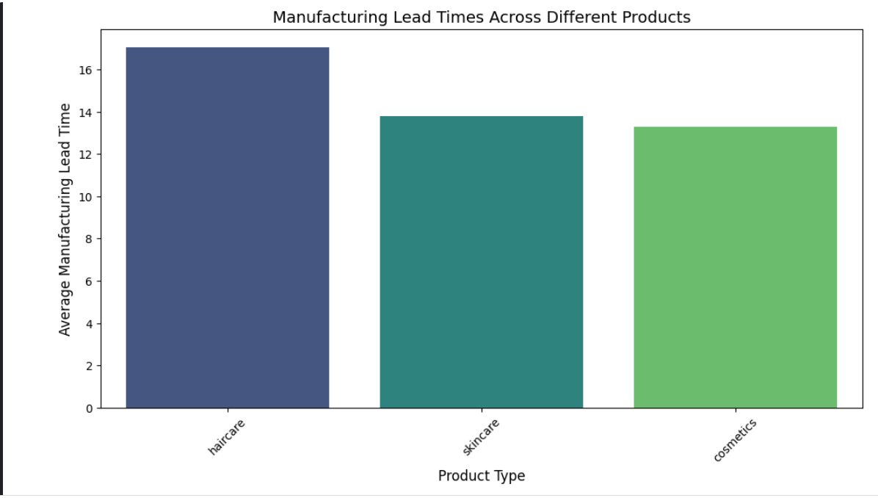

**Haircare products have the longest manufacturing lead times, while skincare and cosmetics take less time.** The bar chart visually confirms these differences in production efficiency.

1. Which suppliers have the lowest defect rates?

(SQL)

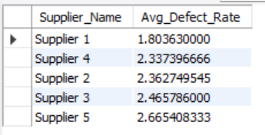 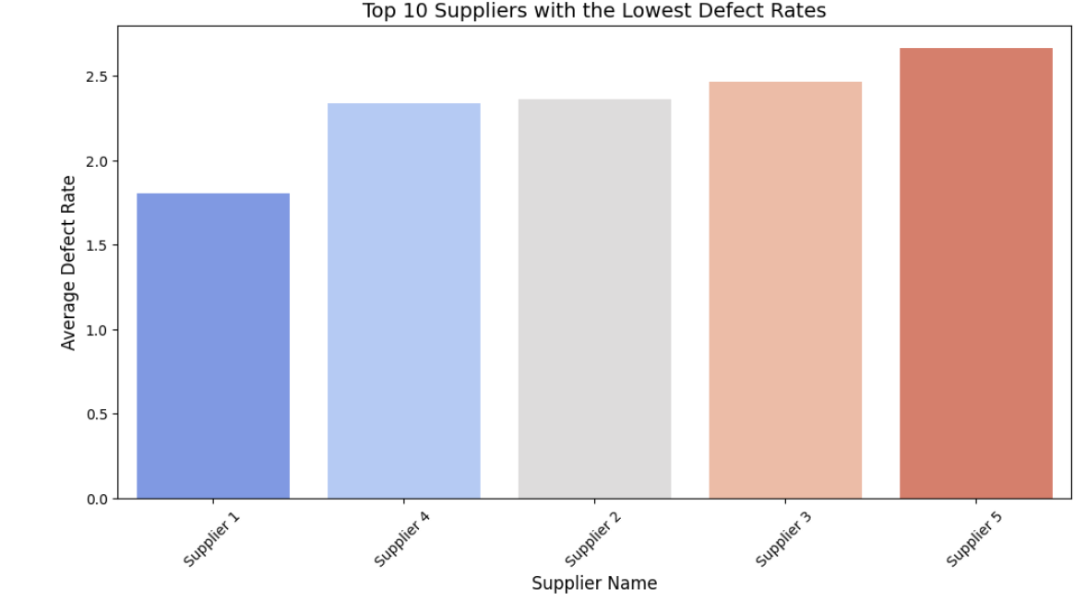

**Supplier 1 has the lowest defect rate, making it the most reliable option.** The bar chart confirms variations among suppliers, helping in quality-driven supplier selection.

1. How do manufacturing costs vary by product type and supplier?

(SQL) (Python)

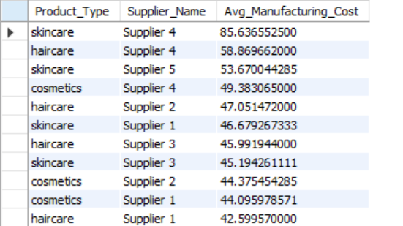 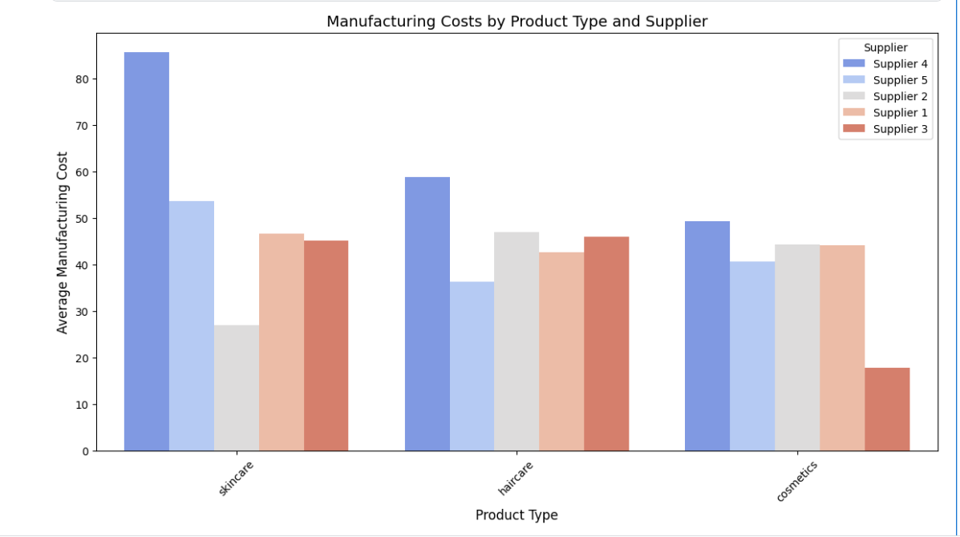

**Manufacturing costs vary significantly by supplier and product type, with Supplier 4 having the highest costs for skincare.** The bar chart highlights cost differences, helping identify the most cost-efficient suppliers.

1. What is the impact of production volumes on defect rates?

(SQL) (Python)

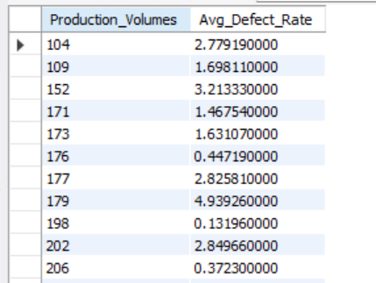 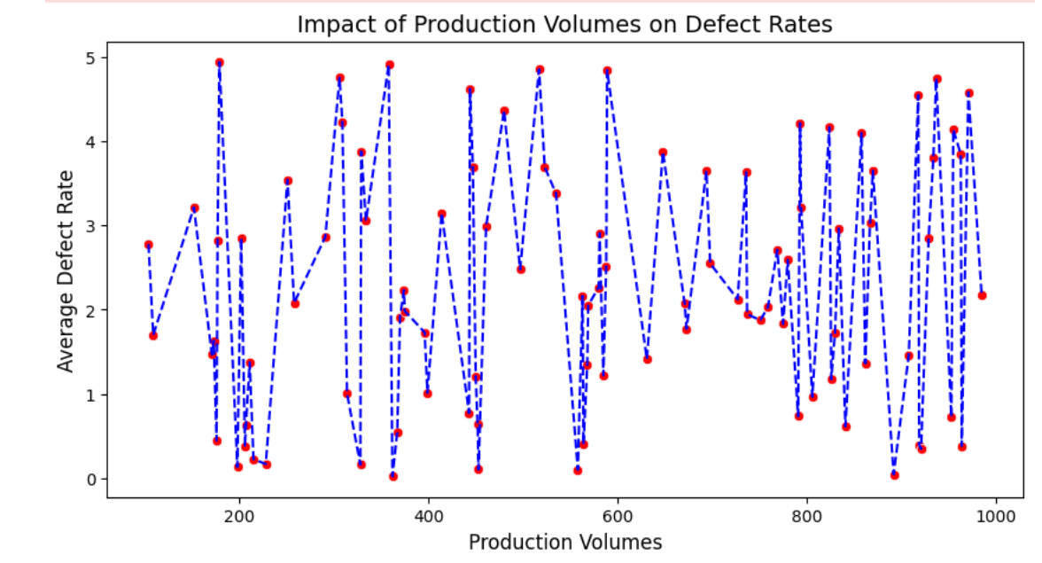

**Defect rates fluctuate with production volumes, showing no clear linear relationship.** Higher production volumes do not consistently lead to higher or lower defect rates, indicating other influencing factors.

**Shipping & Logistics**

1. Which shipping carriers provide the fastest delivery times?

(SQL) (Python)

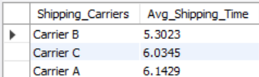 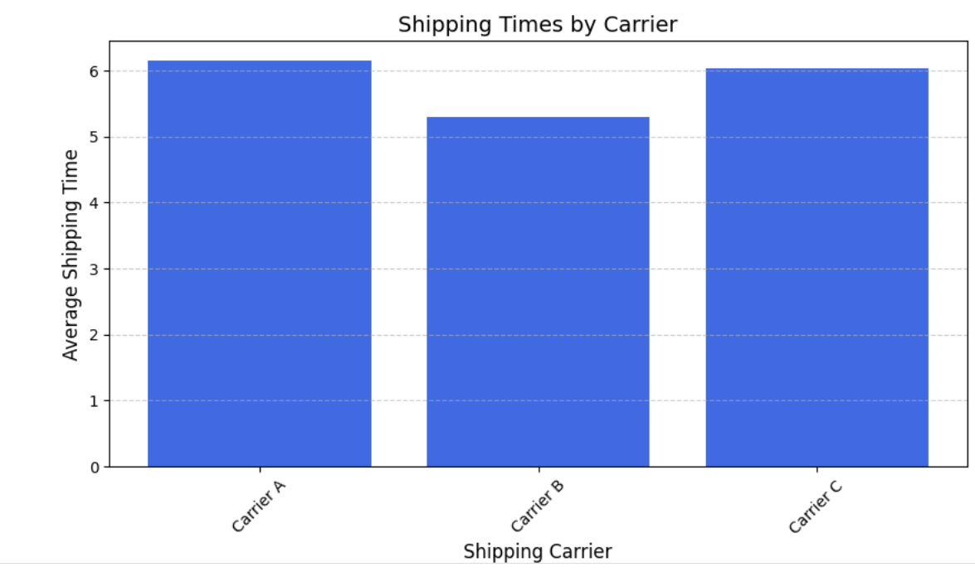

**Carrier B** provides the **fastest delivery time** with an average of **5.30 days**, while **Carrier A and Carrier C** have longer delivery times of **6+ days**.

1. What is the average shipping time per product type or SKU?

(SQL) (Python)

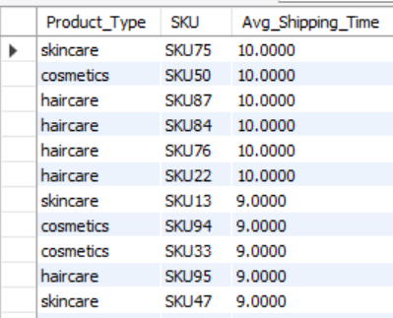 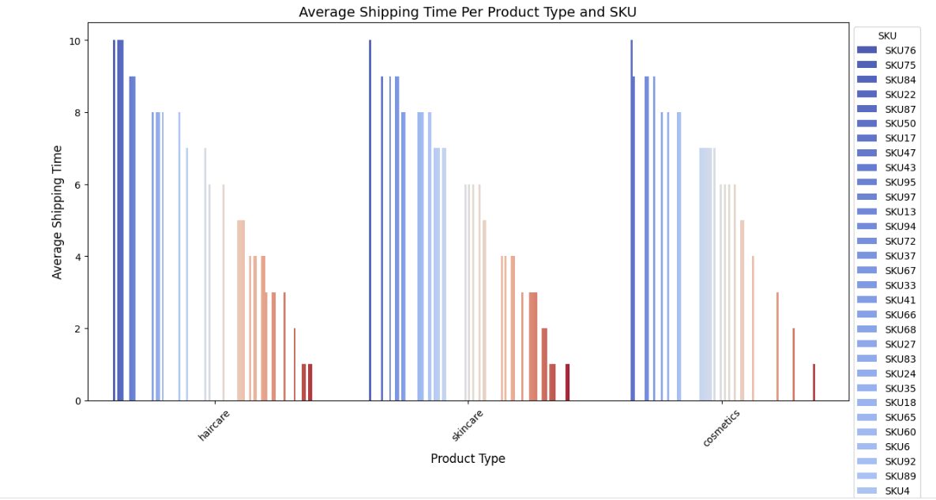 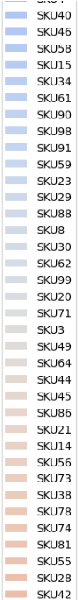 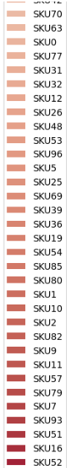

**Skincare products generally have the longest shipping times, while cosmetics and haircare have slightly lower averages.** The bar chart highlights SKU-level variations in shipping time.

1. How do shipping costs vary across different transportation modes?

(SQL) (Python)

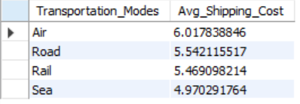 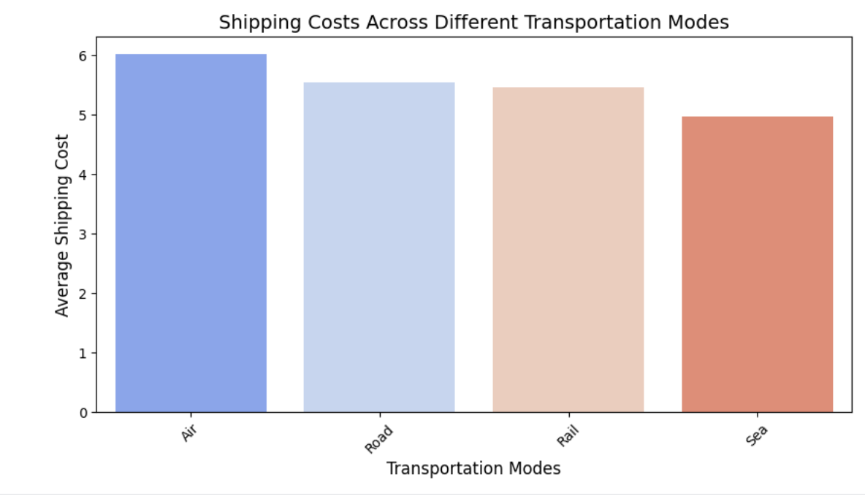

**Air transport has the highest shipping costs, while Sea is the most cost-effective mode.** The bar chart confirms this trend, helping optimize transportation choices.

1. What is the most cost-effective transportation mode for each product category?

(SQL)

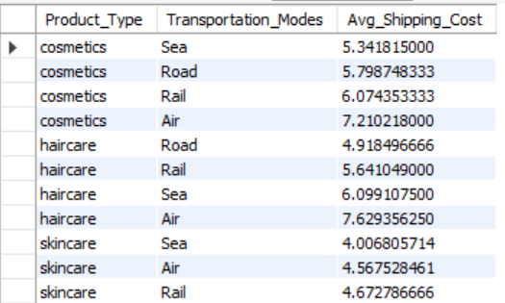 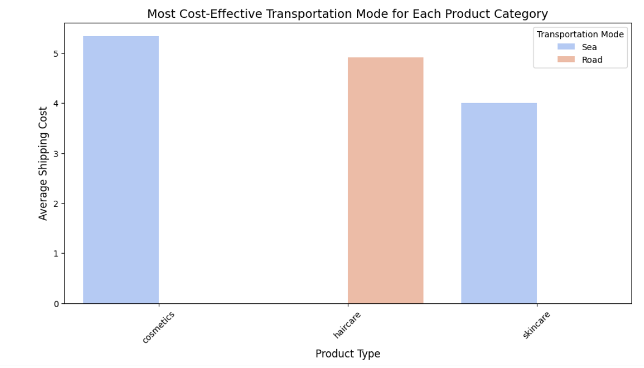

**Sea and Rail are the most cost-effective transportation modes for cosmetics, haircare, and skincare.** The bar chart highlights the lowest shipping costs for each product category.

1. Are there significant delays in shipping times due to specific routes or carriers?

(SQL) (Python)

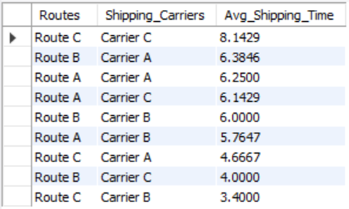 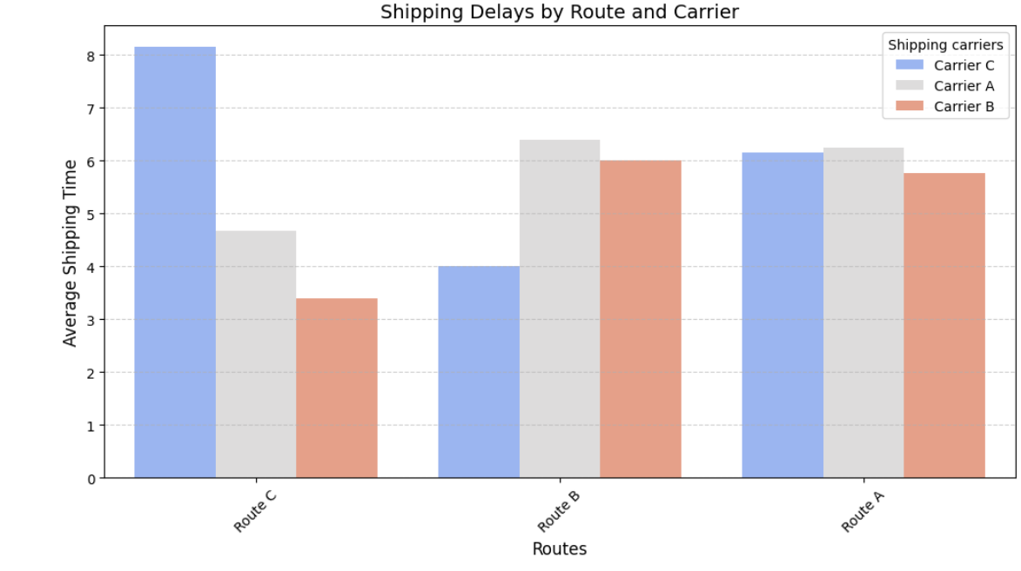

**Route C with Carrier C** experiences the **longest shipping delays** (8.14 days), while **Route C with Carrier A** has the shortest shipping time (3.4 days). **Significant variations exist across routes and carriers, indicating potential inefficiencies.**

**Customer & Market Trends**

1. Which customer demographics purchase the most products?

(SQL) (Python)

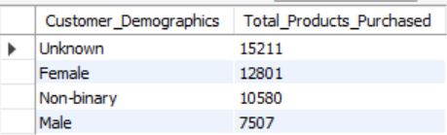 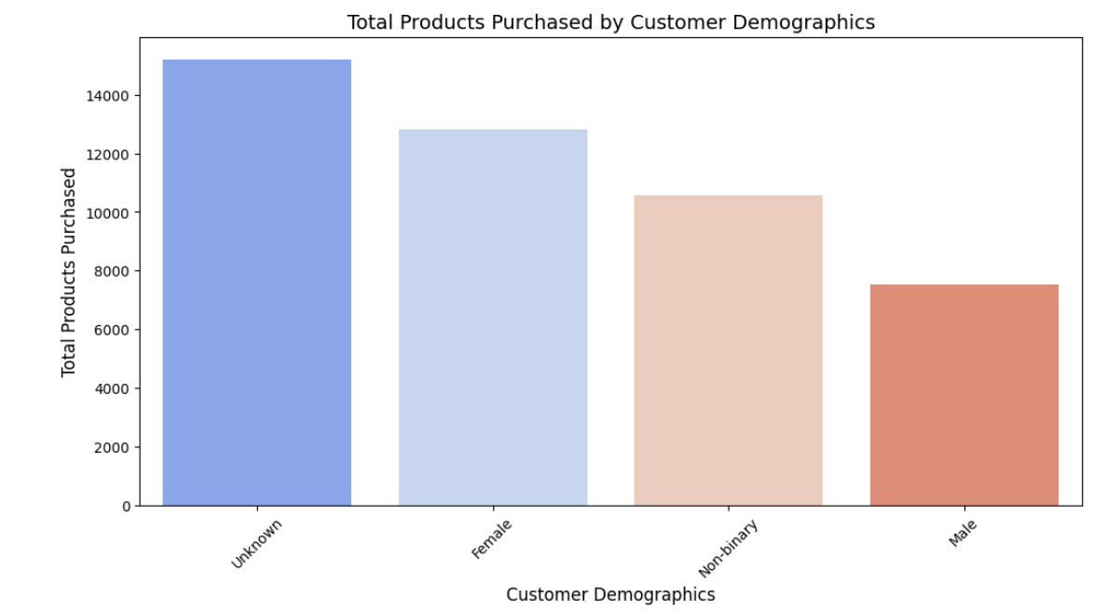

**The 'Unknown' and Female demographics purchase the most products, while Males buy the least.** The bar chart confirms this pattern, showing clear purchasing differences across customer groups.

1. What is the relationship between customer demographics and order quantities?

(SQL) (Python)

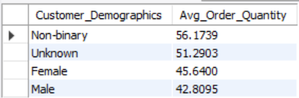 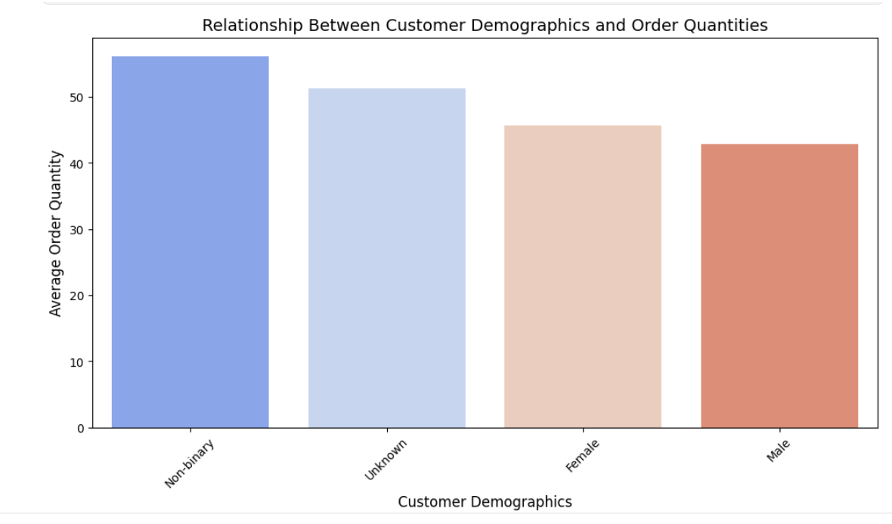

**Non-binary and 'Unknown' customers place the highest average order quantities, while males order the least.** The bar chart confirms this trend, indicating demographic-based purchasing behaviors.

1. Are certain product types more popular in specific locations?

(SQL) (Python)

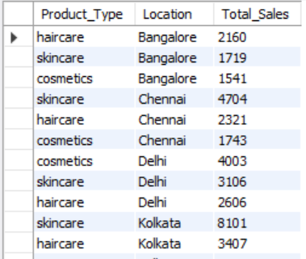 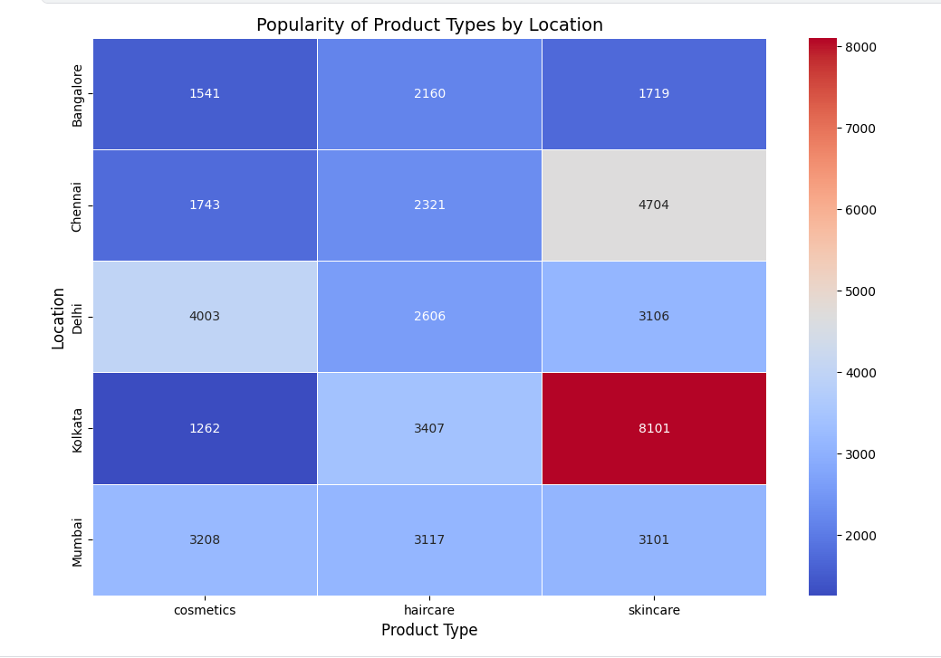

**Skincare is most popular in Kolkata, while haircare dominates in Bangalore and Chennai.** The heatmap confirms regional product preferences for optimized inventory.

1. How do shipping times and costs affect customer purchasing behavior?

(SQL) (Python)

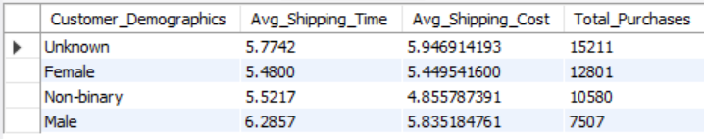 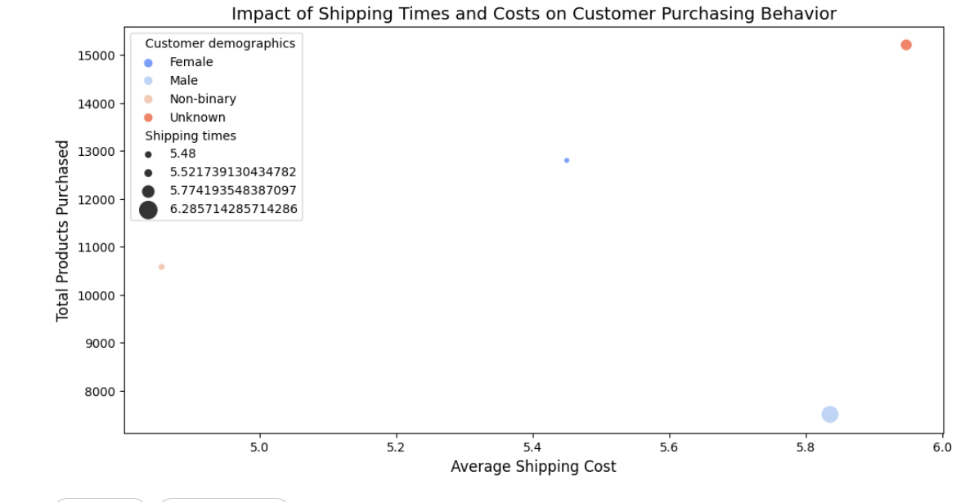

**Customer demographics with lower shipping times and costs tend to make more purchases.**  
The "Unknown" and "Female" categories show the highest purchases, correlating with relatively lower shipping costs and times. **Longer shipping times (e.g., Male) are associated with fewer total purchases, indicating that faster delivery improves customer purchasing behavior.**

**Cost & Efficiency Optimization**

1. How do lead times impact revenue generation?

(SQL) (Python)

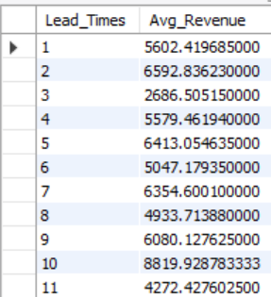 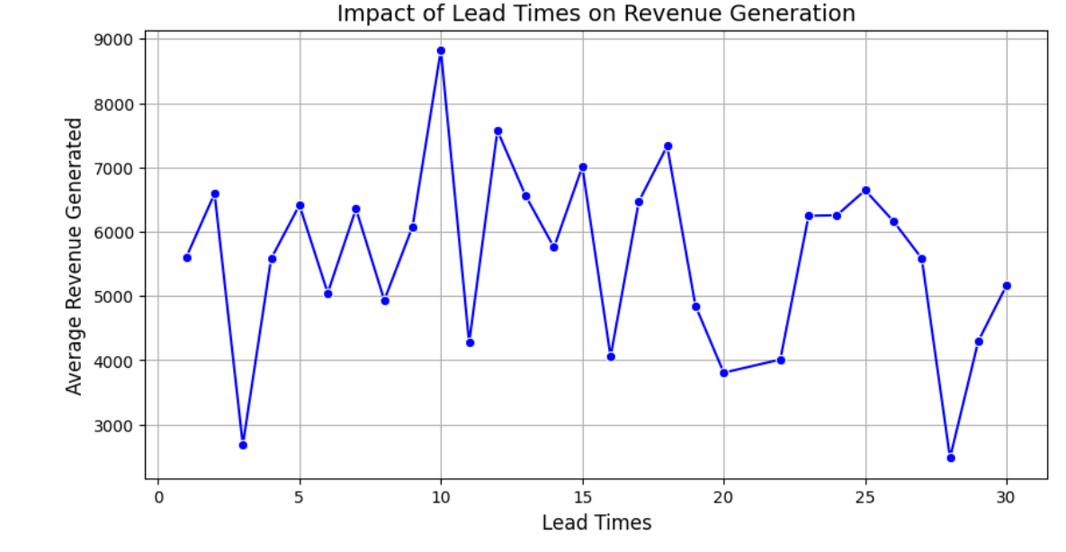

Revenue generation fluctuates with lead times, showing no clear linear correlation. However, shorter and moderate lead times generally correspond to higher revenue, suggesting that reducing lead times may improve sales.

1. Are there cost-saving opportunities by switching suppliers or shipping carriers?

(SQL) (Python)

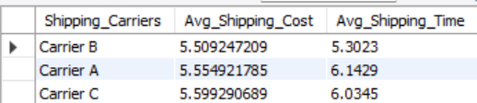 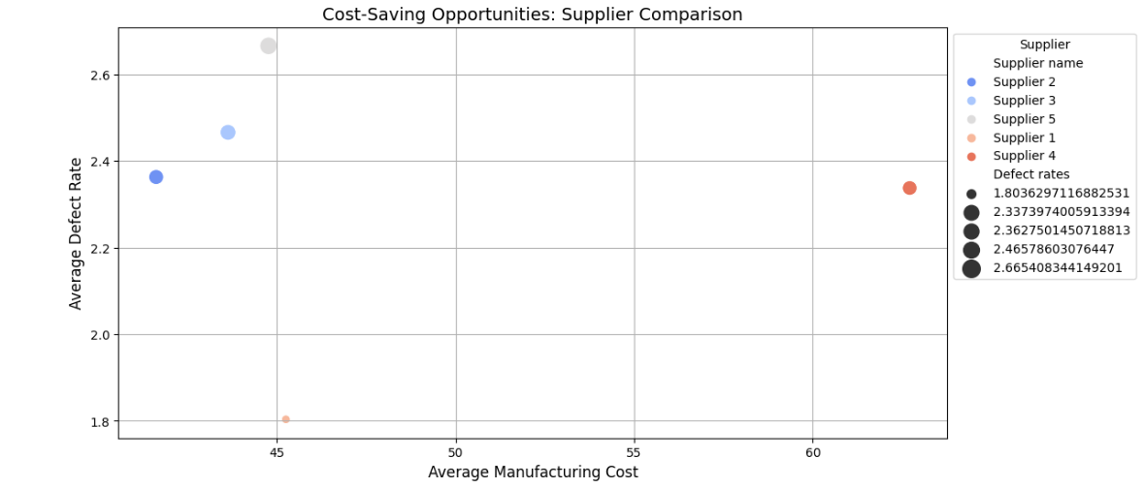 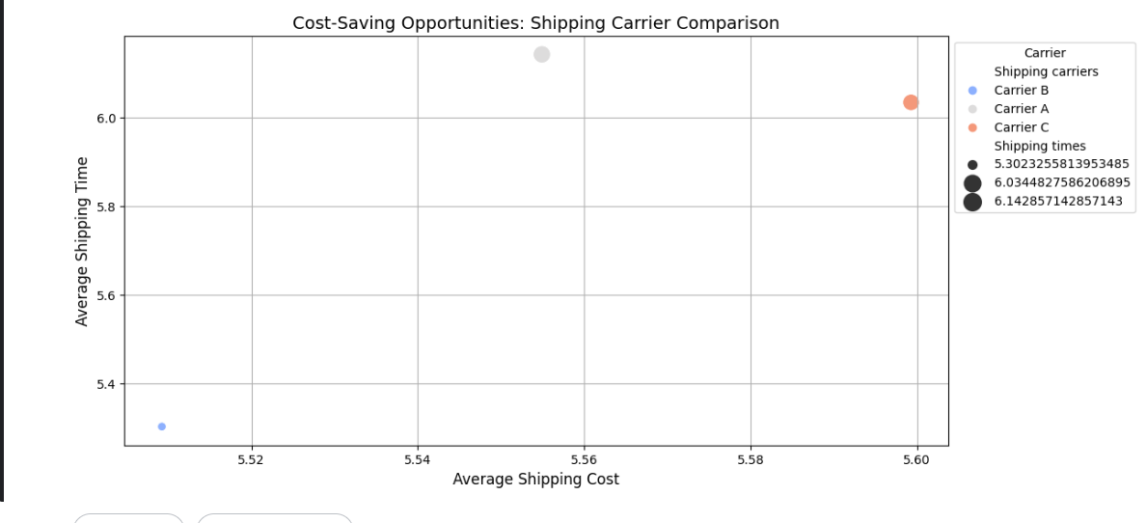

**Carrier B** offers the **lowest shipping costs and fastest delivery times**, indicating a cost-saving opportunity by switching from **Carriers A or C**. Similarly, evaluating supplier costs and defect rates can **help identify more efficient alternatives**.

1. What are the costliest elements in the supply chain?

(SQL) (Python)

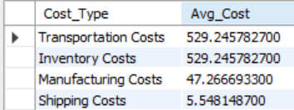 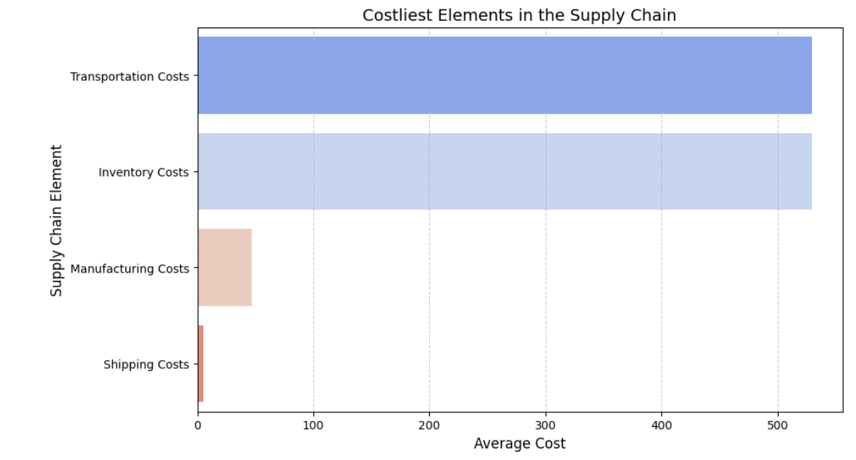

Transportation and inventory costs are the most significant expenses in the supply chain, while manufacturing and shipping costs are relatively lower. Optimizing transportation and inventory management could lead to major cost savings.

1. What strategies can be implemented to reduce defect rates?

(SQL) (Python)

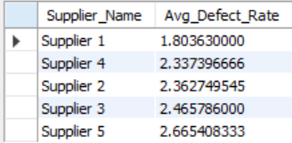 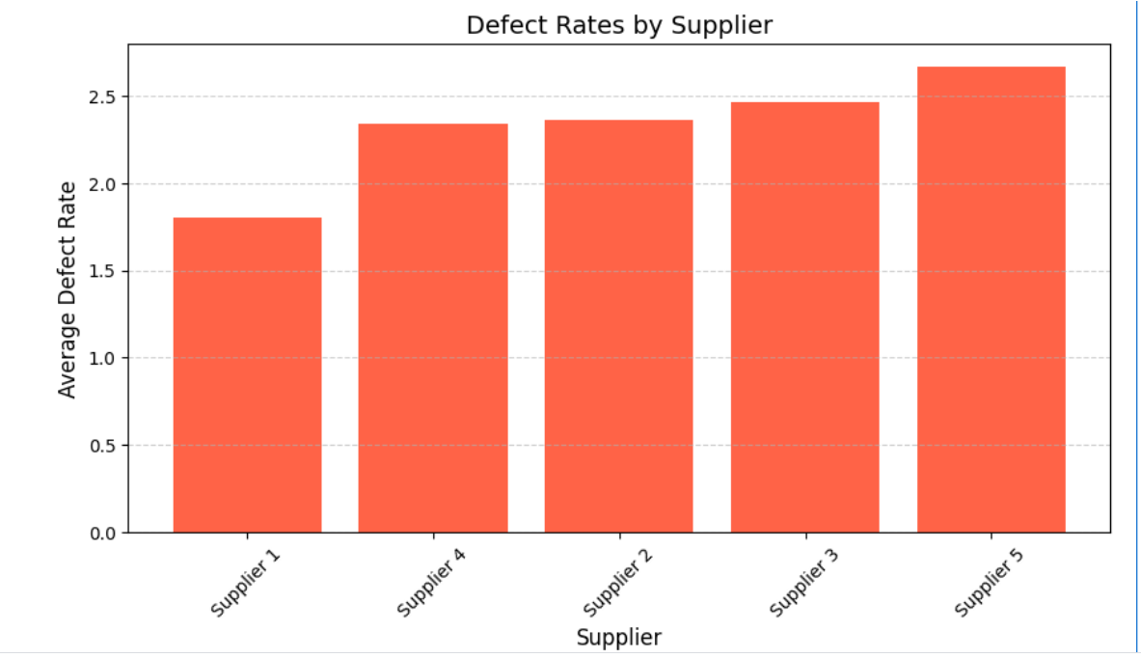

**Supplier 1** has the **lowest defect rate (1.80)**, while **Supplier 5** has the **highest (2.67)**. Strategies to reduce defect rates include **enhanced quality control, supplier audits, and process improvements.**

1. How do transportation costs impact overall profitability?

(SQL) (Python)

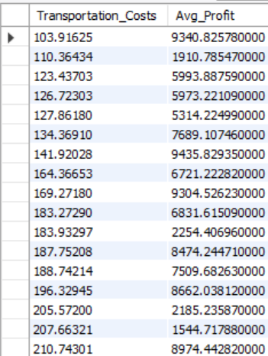 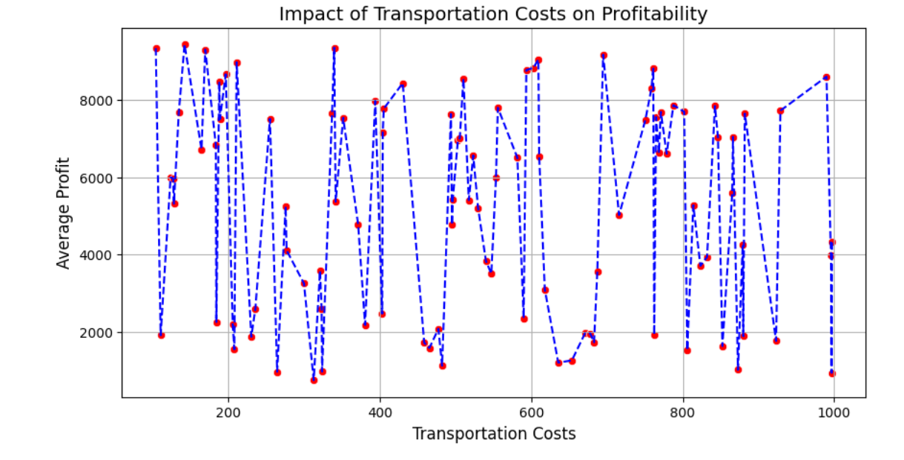

Higher transportation costs do not show a clear correlation with profitability, as profits fluctuate across different cost levels. This suggests that other factors also influence overall profitability.